‘Star Wars,’ Elvis and Me: Anything could have defined my generation, but it happened to be Luke, lightsabers and the Force.
By A. O. SCOTTOCT. 28, 2015
Three important things happened in the middle of 1977, each separated by a little more than a month: “Star Wars” was released, I celebrated my 11th birthday and Elvis Presley died. One of those things is not like the others, I know, and strictly speaking there wasn’t then and isn’t now anything beyond calendar coincidence that links them together. But those random events nonetheless go a long way toward explaining my relationship to popular culture.
And not only mine, of course. Modern life is a series of generational milestones. We calibrate our collective identities according to the shared experience of public events, including hit movies and popular songs. Whether we like them or not, those become part of the architecture of our private selves and also a kind of currency we trade with our peers. Elvis, in his mid-40s at the time of his death, was for kids like me immutably the property of the old, a reminder of the moment in our parents’ youth when everything had changed. The Beatles represented a similar, slightly more recent earthquake: They too belonged to the past. We had sung their songs in nursery school and heard them on “Sesame Street.” Nostalgia had claimed them. “Star Wars” was different. It was ours — our own special tectonic shift, after which the landscape was forever altered.
Or so the story goes, in both its heroic and tragic versions. The wild success of the film now known as “Episode IV — A New Hope” has been held responsible for much of what followed, the good along with the bad. “Star Wars” supposedly helped put an end to the risk-taking and artistic ambition of 1970s New Hollywood and ushered in an era of blockbuster domination that continues to this day. Twenty-first century grown-ups who bemoan the hegemony of fantasy-based franchise movies — which is to say most of us, at one time or another — have only our own youthful enthusiasms to blame. But the first “Star Wars” trilogy is also credited with opening up a dazzling world of fan culture, liberating nerds and geeks from the condescension of their elders and the mockery of their classmates and placing their passions at the center of the universe. Like rock ’n’ roll before it, this cultural dispensation may not have been immediately respectable, but it proved to be instantly profitable and endlessly renewable.
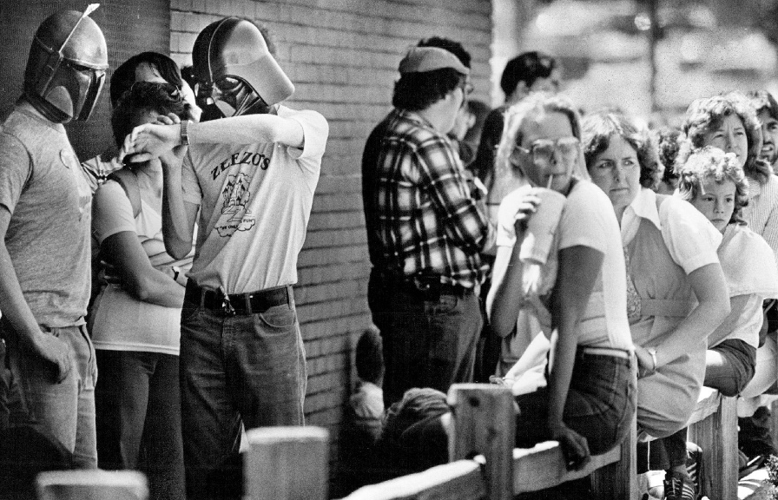
Fans of the “Star Wars” franchise in 1980. Credit John Sunderland/The Denver Post, via Getty Images
How new was it, really? History has a way of making novelty look secondhand. Elvis made his indelible mark on baby boomer consciousness by putting a white face and an adolescent pout on a style of black Southern music that had been around a long time. Beatlemania was built mostly on echoes of Elvis and Chuck Berry. “Star Wars” was, if anything, an even more self-conscious throwback, a film student’s act of promiscuous homage, a hodgepodge of styles and allusions.
Photo
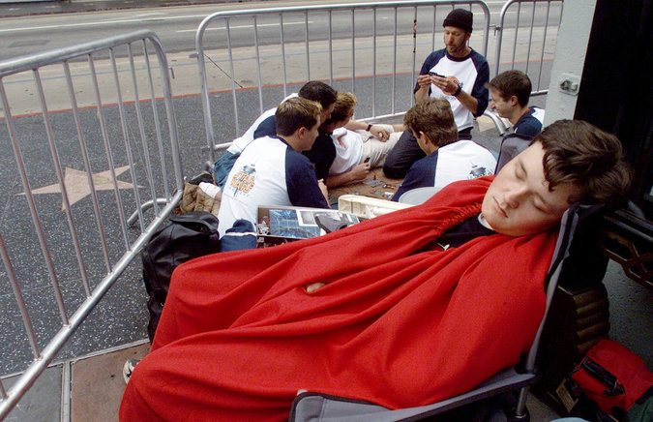
Awaiting a screening of “Attack of the Clones” in 2002. CreditFred Prouser/Reuters
In his generous, slightly patronizing New York Times review, Vincent Canby noted the movie’s evocation of “Flash Gordon” serials and “a variety of literature that is nothing if not eclectic: ‘Quo Vadis?,’ ‘Buck Rogers,’ ‘Ivanhoe,’ ‘Superman,’ ‘The Wizard of Oz,’ ‘The Gospel According to St. Matthew,’ the legend of King Arthur and the knights of the Round Table.” George Lucas’s fellow cinephiles could point out his debts to John Ford and Akira Kurosawa. “Star Wars” might have looked like science fiction and played like an aerial-combat film, but it was also a western, a samurai epic and, at least when Carrie Fisher and Harrison Ford were on screen together, a screwball comedy. An exemplary act of what some of us would learn, in college a few years later, to identify as the distinctive postmodern aesthetic strategy of pastiche.
But what, at the time, did any of us know about any of that? If you were 11 in 1977, “Star Wars” was something new under the sun. Which doesn’t mean we thought it came out of nowhere. There were action-adventure movies, multi-sequel science-fiction allegories, comic books that had initiated generations of fans in the pleasures of serial narration. There was “The Lord of the Rings” (the books and Ralph Bakshi’s animated movie); “Planet of the Apes” (the movie and the animated Saturday morning cartoon spinoff); “Star Trek”; Mad magazine. Plenty of fuel to feed a fan’s budding imagination.
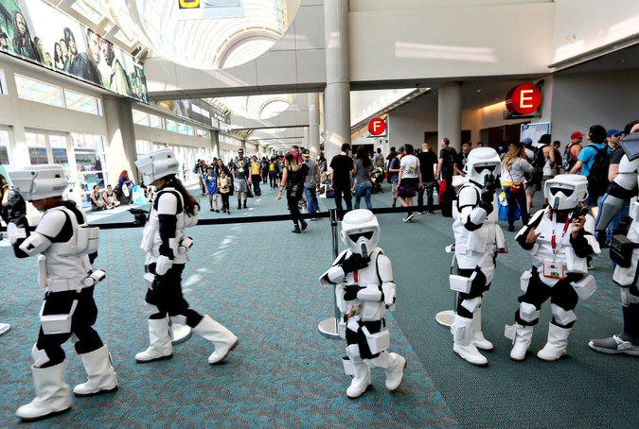
Budding Stormtroopers in 2015. CreditSandy Huffaker/Reuters
All of those were the kindling, and it’s possible that if Mr. Lucas hadn’t struck the match, the explosion would have happened anyway. What ignited in the summer of 1977 may not have been only — even primarily — the love of a particular film. In retrospect, the larger phenomenon of “Star Wars” represented what looks like the inevitable product of demographic and social forces.
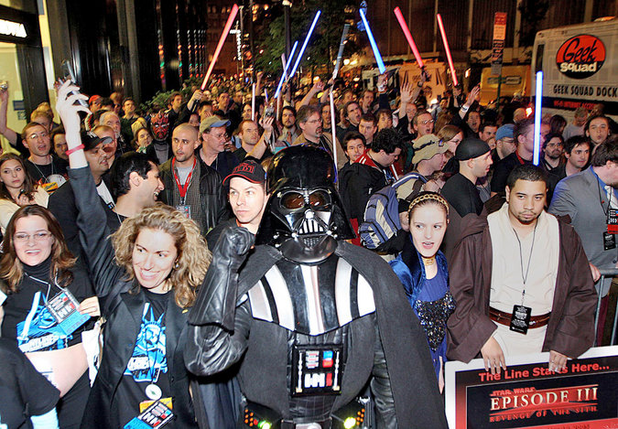
Suiting up for “Revenge of the Sith” in 2005. CreditSeth Wenig/Reuters
The “great man” theory of history always does battle with more deterministic accounts. Here was the nascent population not yet known as Generation X, hungry for novelty, distraction, comfort, order, mythology, heroism — whatever it was that our post-’60s, recessionary moment seemed not to be supplying. All we needed was a baby boomer to give it to us, get rich in the process and incur both our worship and our resentment for the rest of our lives. He would be the inventor, but we would be the end users, and we would make the thing ours. What was true of “Star Wars” would be true, a few years later, of the personal computer. And both would eventually provide a further generational bridge, between the now-graying X-ers and the ascendant millennials.
But more about that in a minute. I’m the ancient mariner here, and this is still my story. I’m not sure how many times I saw “Star Wars” the year it came out, but I am certain that until the arrival of my children, a DVD player and a copy of “Toy Story 2,” there is no movie I have seen as often in such rapid succession.
The novelist Jonathan Lethem, two years older than I am, has written (in a piercing essay called “13, 21, 1977”) about seeing it 21 times, usually by himself, during an especially painful period in his life. I can’t quite match that total, and there was no pattern to the viewings. I think my parents took me the first time. Later, I took my little sister. Another time I went with a girl from my sixth-grade class on some awkward early approximation of a date. At least one friend’s birthday party involved a “Star Wars” outing. Going to see it was, in my recollection, a casual habit. You would be in someone’s rec room playing air hockey, or trying to pop wheelies on your bike, and you’d get bored with that and, if you hadn’t already spent your allowance, you’d head to the theater where the movie had been playing continuously since the end of the previous school year. It was something to do.
For some, like Mr. Lethem, it was also a gateway into more sophisticated cinematic pleasures, and a first step on a backward path through movie history. In his case, “Star Wars” was replaced first by “2001: A Space Odyssey” and then by “The Searchers,” both of them, not coincidentally, among the identifiable ancestors of “A New Hope.” Others held fast to childish things and formed a Rebel Alliance against the Empire of adulthood. It’s hardly an accident that J. J. Abrams, director of “Star Wars: The Force Awakens,” is one of us. He turned 11 about two weeks before I did.
The legend of “Star Wars” was something that arose later. In 1977, we were innocent of Joseph Campbell and the further annotations Mr. Lucas and others would provide. The allegorical meanings — the battle of good and evil, the mystery of the Force — rest lightly on the jaunty surface of “A New Hope.” There would be richer intimations of depth and darkness in “The Empire Strikes Back” and “Return of the Jedi,” or maybe, since we were a few years older, we were more inclined to see them.
And then we kind of moved on, at least until 1999, when Mr. Lucas returned with “The Phantom Menace” and the Gen X legacy of ambivalence and confusion blossomed anew. That movie was terrible! So was “Attack of the Clones.” But it didn’t seem to matter. Everyone went to see those movies anyway, and the awfulness cast a rosy and perhaps unmerited glow on the first trilogy. Those movies weren’t all that good either. And that didn’t matter. They existed — the whole cosmos, or gestalt, or whatever it is, exists — in a realm beyond such judgments, and also beyond the ordinary operations of nostalgia. “Star Wars” is an old movie now, older now than Elvis Presley’s first records were in 1977. The film moves slowly and shows its predigital seams. It’s more charming than sublime, a silly pop-culture throwaway full of funny creatures, terrible dialogue and breathless acting. It’s exactly the same as I remember it, and watching it again I wonder what I ever saw in it. I find my lack of faith disturbing. And yet, I’m still a believer.
For another take on “Star Wars” fans, read Manohla Dargis’s essay.

